**User Excel Management**

**Description**

This module is for managing user data efficiently. It is enabled with streamline user creation with random password, user updates and user deletion and it is integrated with excel import export where it is possible to manage user data in bulk using excel file.

**Typical Usage Scenario**

When there is need to import and export user data from excel in large amount or need to update or delete large amount of user data then it is reliable to use.

**Features and Limitations**

* Create User with random password.
* Update user.
* Delete User.
* Users export to excel file.
* Downloads excel template.
* Create, Update, delete users in bulk by excel import.
* Operations can only be applied on FullName, Email, Role, Active, Name, Password attributes of System.User and Administration.Account entity.
* It takes user’s Name value from email by removing email’s @ sign and domain name.
* Developers cannot add other attributes to it.
* Deletion of current user (who is doing excel import) is not possible only change is possible.

**Dependencies**

* Mendix Studio Pro 9.24.0
* [MxReflection](https://docs.mendix.com/appstore/modules/model-reflection/)
* [Excel Importer](https://docs.mendix.com/howto/integration/importing-excel-documents/)
* [Excel Exporter](https://academy.mendix.com/link/modules/136/lectures/1252/7.1-Using-the-Excel-Exporter-to-Export-Data)
* [Community Commons](https://docs.mendix.com/appstore/modules/community-commons-function-library/)

**Installation**

Setting up User Excel Management module in your application

1. Download and install all prerequisite modules in your application.
2. Create a page **User_Overview** and add the snippet **SNIP_UserOverview** inside it from inside **UserExcelManagement module >USE_ME**.
3. Add the following pages to the navigation:

**MxModelReflection.MxObjects_Overview**:

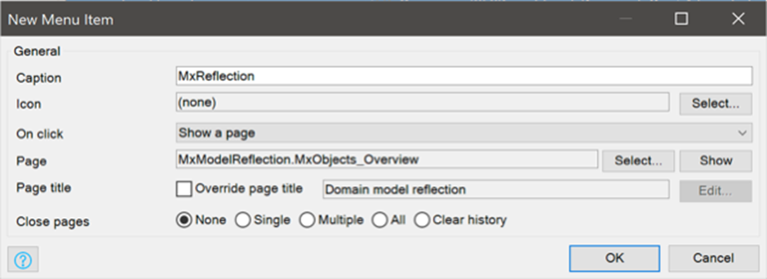

**XLSReport.Excel_Document_Overview**:

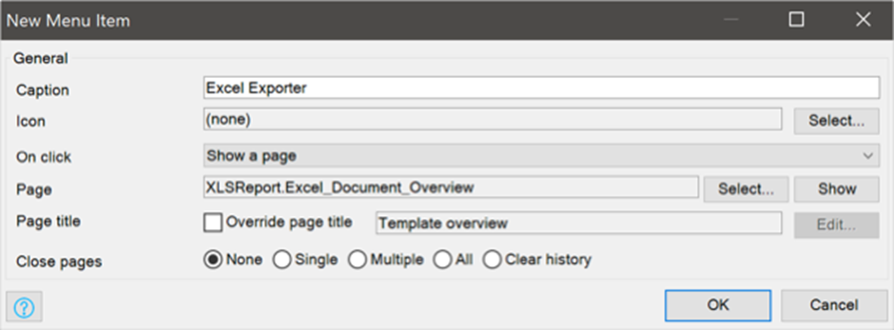

1. Create menu items for the **ExcelImportOverview** and the **MxObjects_Overview** pages in navigation (these pages already exist in the **USE_ME** folders of the downloaded modules **ExcelImporter**).
2. Run the App.
3. Go to mx reflection from navigation.
4. Synchronize following modules:
   1. Administration
   2. ExcelImporter
   3. MxModelReflection
   4. System
   5. UserExcelManagement
   6. XLSReport

1. Setup template for export to excel.
   1. **Configuring the Basic Template Setup**
      1. Run your app.
      2. View the App.
      3. Click button new to create a new template. Set the **filename** as ***UserExport,*** **Document Type** as ***Excel 2007 and higher*** and select **Input Object** as ***UserExcelManagement.Product_excel***  then save and next.
      4. Select **dd-mm-yyyy** format for **date time export format** and select this excel file [UserExport](https://word-edit.officeapps.live.com/we/UserExport.xlsx)  upload existing excel file. You can also refer image below.

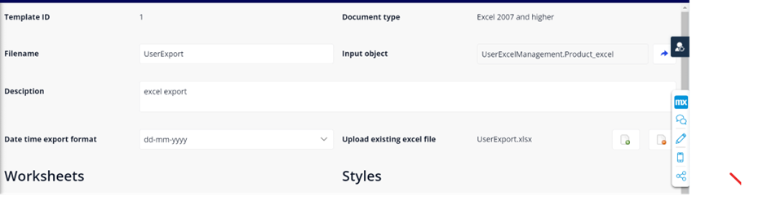

* + 1. Under worksheets section click on new button.
    2. Set the following properties.
       1. Name: **User**
       2. Row Object: **UserExcelManagement.User**
       3. Reference to template input object: **UserExcelManagement.User_product_excel**.
       4. Sheet input object: **UserManagement.Product_excel.**
       5. Start retrieved data at row: **1.**

You can also refer the image below.

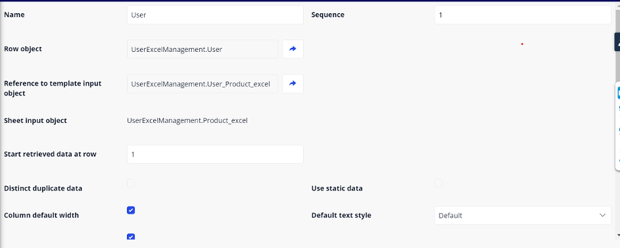

* 1. Add the columns by clicking new button inside column data. Please refer following image below for columns.

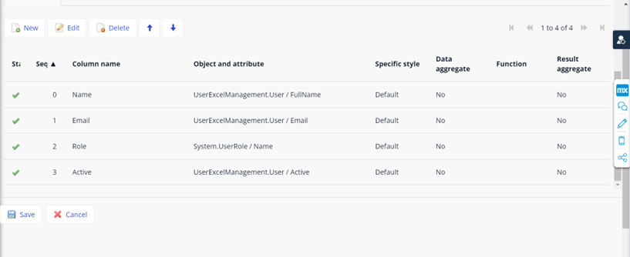

* 1. Now click on save and save the template**.**

1. **Now Setup template for Excel Import.**
2. Go to excel import page from navigation.
3. Click on new template and fill the following.
   1. Name: **User_Import**
   2. Mendix Object: **UserExcelManagement.ExcelUser**
   3. Sheet number: **1**
   4. Header row number: **1**
   5. Import action: **synchronize objects**
   6. Import from row number: **2**

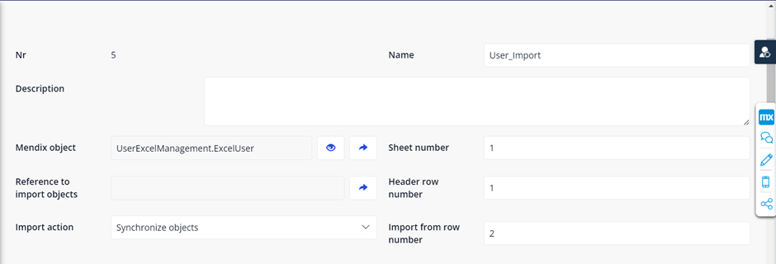

You can also refer image below.

1. Now connect columns to attribute by clicking new button inside column section and refer the image below for columns setup.

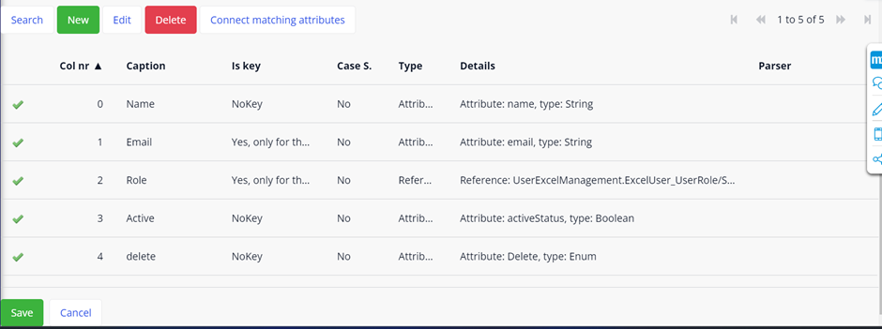

**Note:** if you want to change the name of templates for excel export then make sure the name of template is same as inside the **USE_ME>microflows>ACT_ExportToExcel** “RetrieveMxTemplate from database” activity see in image below:

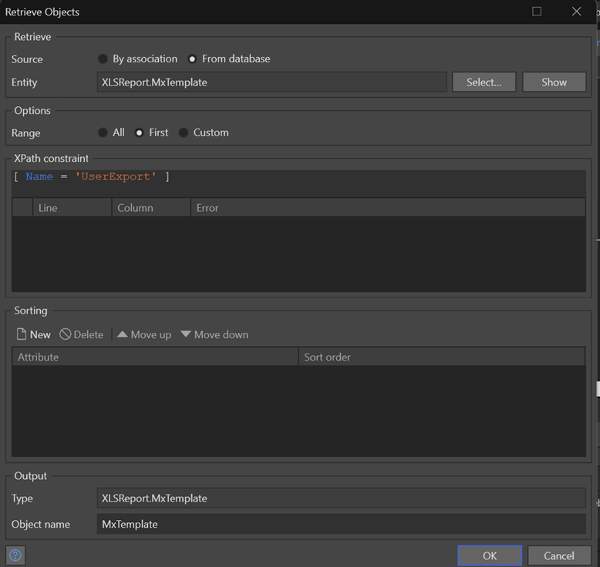

For excel import do the same with **ACT_OpenImportPage** file inside **USE_ME>microflows** open “RetrieveMxTemplate from database” activity see in image below:

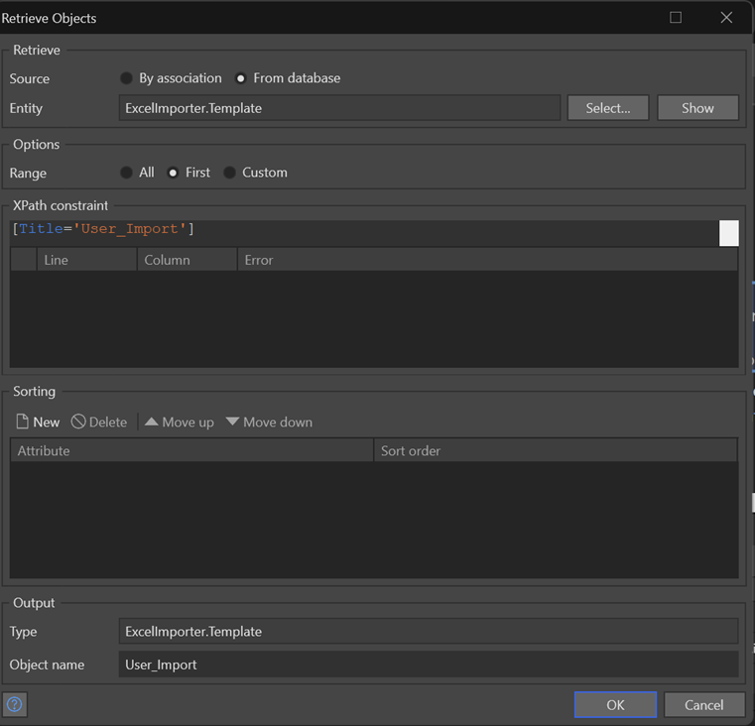

1. Add the **User_Overview** page to navigation and run the app.
2. View the app and go to **User_Overview** page, now you can do excel import export and crud operations on users.

**Note:** If you want to learn more about excel import refer this document for [excel import](https://docs.mendix.com/howto/integration/importing-excel-documents/).

**Configuration: NA**

**Category: Module**

**Subcategory: All**

**Visibility: Public Marketplace**

**Studio Pro Version: 9.24.0**